TRANG 17

a)

|  |  |  |  |  |  |  |
| --- | --- | --- | --- | --- | --- | --- |
| p | q | p → q | ¬p | ¬q | ¬q → ¬p | (p → q) ↔ (¬q → ¬p) |
| 0 | 0 | 1 | 1 | 1 | 1 | 1 |
| 0 | 1 | 1 | 1 | 0 | 1 | 1 |
| 1 | 0 | 0 | 0 | 1 | 0 | 1 |
| 1 | 1 | 1 | 0 | 0 | 1 | 1 |

b)

|  |  |  |  |  |
| --- | --- | --- | --- | --- |
| p | q | p → q | q → p | (p → q) → (q → p) |
| 0 | 0 | 1 | 1 | 1 |
| 0 | 1 | 1 | 0 | 0 |
| 1 | 0 | 0 | 1 | 1 |
| 1 | 1 | 1 | 1 | 1 |

c)

|  |  |  |  |  |  |
| --- | --- | --- | --- | --- | --- |
| p | q | p ↔ q | ¬q | p ⊕ ¬q | (p ↔ q) ∨ (p ⊕ ¬q) |
| 0 | 0 | 1 | 1 | 1 | 1 |
| 0 | 1 | 0 | 0 | 0 | 0 |
| 1 | 0 | 0 | 1 | 0 | 0 |
| 1 | 1 | 1 | 0 | 1 | 1 |

d)

|  |  |  |  |  |  |
| --- | --- | --- | --- | --- | --- |
| p | q | p ⊕ q | ¬q | p ⊕ ¬q | (p ⊕ q) → (p ⊕ ¬q) |
| 0 | 0 | 0 | 1 | 1 | 1 |
| 0 | 1 | 1 | 0 | 0 | 0 |
| 1 | 0 | 1 | 1 | 0 | 0 |
| 1 | 1 | 0 | 0 | 1 | 1 |

0)

|  |  |  |  |  |  |  |
| --- | --- | --- | --- | --- | --- | --- |
| p | q | ¬p | ¬q | ¬p ↔ ¬q | p ↔ q | (¬p ↔ ¬q) ↔ (p ↔ q) |
| 0 | 0 | 1 | 1 | 1 | 1 | 1 |
| 0 | 1 | 1 | 0 | 0 | 0 | 1 |
| 1 | 0 | 0 | 1 | 0 | 0 | 1 |
| 1 | 1 | 0 | 0 | 1 | 1 | 1 |

g)

|  |  |  |  |  |  |
| --- | --- | --- | --- | --- | --- |
| p | q | r | p ∨ q | ¬r | (p ∨ q) ∧ ¬r |
| 0 | 0 | 0 | 0 | 1 | 0 |
| 0 | 0 | 1 | 0 | 0 | 0 |
| 0 | 1 | 0 | 1 | 1 | 1 |
| 0 | 1 | 1 | 1 | 0 | 0 |
| 1 | 0 | 0 | 1 | 1 | 1 |
| 1 | 0 | 1 | 1 | 0 | 0 |
| 1 | 1 | 0 | 1 | 1 | 1 |
| 1 | 1 | 1 | 1 | 0 | 0 |

i)

|  |  |  |  |  |  |  |
| --- | --- | --- | --- | --- | --- | --- |
| p | q | r | p ↔ q | ¬q | ¬q ↔ r | (p ↔ q) ∨ (¬q ↔ r) |
| 0 | 0 | 0 | 1 | 1 | 0 | 1 |
| 0 | 0 | 1 | 1 | 1 | 1 | 1 |
| 0 | 1 | 0 | 0 | 0 | 1 | 1 |
| 0 | 1 | 1 | 0 | 0 | 0 | 0 |
| 1 | 0 | 0 | 0 | 1 | 0 | 0 |
| 1 | 0 | 1 | 0 | 1 | 1 | 1 |
| 1 | 1 | 0 | 1 | 0 | 1 | 1 |
| 1 | 1 | 1 | 1 | 0 | 0 | 1 |

j)

|  |  |  |  |  |  |  |  |
| --- | --- | --- | --- | --- | --- | --- | --- |
| p | q | r | ¬p | ¬q | ¬p ↔ ¬q | q ↔ r | (¬p ↔ ¬q) ↔ (q ↔ r) |
| 0 | 0 | 0 | 1 | 1 | 1 | 1 | 1 |
| 0 | 0 | 1 | 1 | 1 | 1 | 0 | 0 |
| 0 | 1 | 0 | 1 | 0 | 0 | 0 | 1 |
| 0 | 1 | 1 | 1 | 0 | 0 | 1 | 0 |
| 1 | 0 | 0 | 0 | 1 | 0 | 1 | 0 |
| 1 | 0 | 1 | 0 | 1 | 0 | 0 | 1 |
| 1 | 1 | 0 | 0 | 0 | 1 | 0 | 0 |
| 1 | 1 | 1 | 0 | 0 | 1 | 1 | 1 |

1RANG 18

a)

|  |  |  |  |
| --- | --- | --- | --- |
| p | q | p ∨ q | q ∨ p |
| 0 | 0 | 0 | 0 |
| 0 | 1 | 1 | 1 |
| 1 | 0 | 1 | 1 |
| 1 | 1 | 1 | 1 |

|  |  |  |  |
| --- | --- | --- | --- |
| p | q | p ∧ q | q ∧ p |
| 0 | 0 | 0 | 0 |
| 0 | 1 | 0 | 0 |
| 1 | 0 | 0 | 0 |
| 1 | 1 | 1 | 1 |

b)

|  |  |  |  |  |  |  |
| --- | --- | --- | --- | --- | --- | --- |
| p | q | r | p ∨ q | (p ∨ q) ∨ r | q ∨ r | p ∨ (q ∨ r) |
| 0 | 0 | 0 | 0 | 0 | 0 | 0 |
| 0 | 0 | 1 | 0 | 1 | 1 | 1 |
| 0 | 1 | 0 | 1 | 1 | 1 | 1 |
| 0 | 1 | 1 | 1 | 1 | 1 | 1 |
| 1 | 0 | 0 | 1 | 1 | 0 | 1 |
| 1 | 0 | 1 | 1 | 1 | 1 | 1 |
| 1 | 1 | 0 | 1 | 1 | 1 | 1 |
| 1 | 1 | 1 | 1 | 1 | 1 | 1 |

|  |  |  |  |  |  |  |
| --- | --- | --- | --- | --- | --- | --- |
| p | q | r | p ∧ q | (p ∧ q) ∧ r | q ∧ r | p ∧ (q ∧ r) |
| 0 | 0 | 0 | 0 | 0 | 0 | 0 |
| 0 | 0 | 1 | 0 | 0 | 0 | 0 |
| 0 | 1 | 0 | 0 | 0 | 0 | 0 |
| 0 | 1 | 1 | 0 | 0 | 1 | 0 |
| 1 | 0 | 0 | 0 | 0 | 0 | 0 |
| 1 | 0 | 1 | 0 | 0 | 0 | 0 |
| 1 | 1 | 0 | 1 | 0 | 0 | 0 |
| 1 | 1 | 1 | 1 | 1 | 1 | 1 |

c)

|  |  |  |  |  |  |  |  |
| --- | --- | --- | --- | --- | --- | --- | --- |
| p | q | r | q ∨ r | p ∧ (q ∨ r) | p ∧ q | p ∧ r | (p ∧ q) ∨ (p ∧ r) |
| 0 | 0 | 0 | 0 | 0 | 0 | 0 | 0 |
| 0 | 0 | 1 | 1 | 0 | 0 | 0 | 0 |
| 0 | 1 | 0 | 1 | 0 | 0 | 0 | 0 |
| 0 | 1 | 1 | 1 | 0 | 0 | 0 | 0 |
| 1 | 0 | 0 | 0 | 0 | 0 | 0 | 0 |
| 1 | 0 | 1 | 1 | 1 | 0 | 1 | 1 |
| 1 | 1 | 0 | 1 | 1 | 1 | 0 | 1 |
| 1 | 1 | 1 | 1 | 1 | 1 | 1 | 1 |

TRANG 19

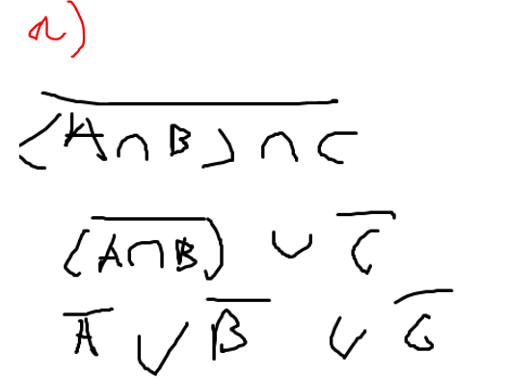

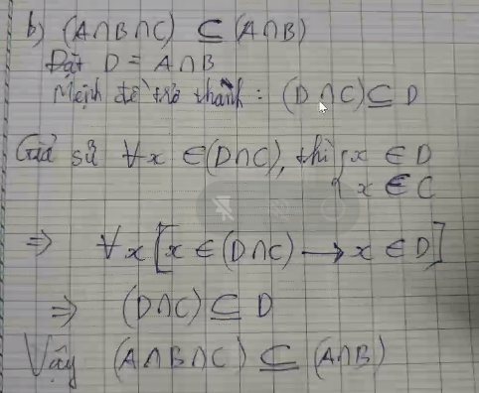

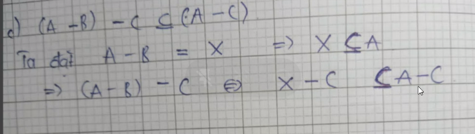

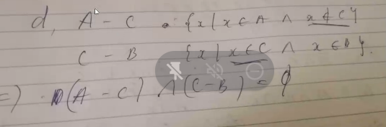

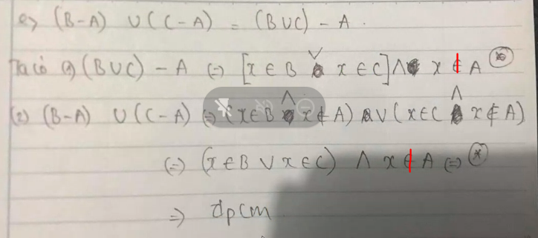

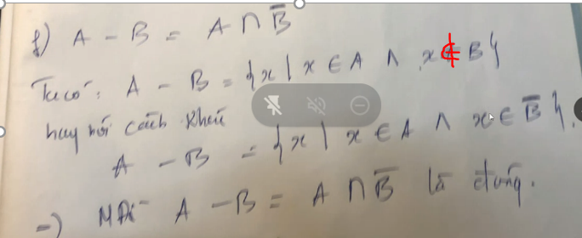

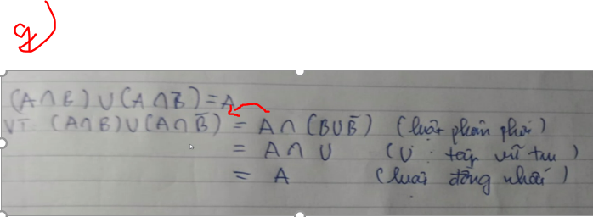

TRANG 33

a) f(x) = x2 + 1, g(x) =

gof = g(f(x)) = $\sqrt{x^{2}+2}$

fog = f(g(x)) = x + 2

b) g(x) = 2x + 1,

- if x > 0

gof = g(f(x)) = $2x^{2}+1$

fog = f(g(x)) = ${\left(2x+1\right)}^{2}$

* if $x≤0$

gof = g(f(x)) = 2x + 3

fog = f(g(x)) = 2x + 2